**AI-DRIVEN EXPLORATION AND PREDICTION OF COMPANY REGISTRATION TRENDS WITH THE REGISTRAR OF COMPANIES**

**(RoC)**

**INTRODUCTION:**

AI-driven exploration and prediction of company registration trends with the RoC represents a transformative approach to understanding the dynamics of the corporate world. By harnessing the capabilities of AI, we can unlock valuable insights from vast datasets that were previously untapped. This innovative approach enables us to not only explore historical registration trends but also make accurate predictions about future trends and the direction of the business ecosystem.

In this era of digital transformation, AI-driven exploration and prediction provide a unique advantage to entrepreneurs, investors, policymakers, and market analysts. By delving deep into the RoC data, AI can identify emerging industries, regional hotspots for business growth, regulatory shifts, and much more. Moreover, it can assist in predicting future market trends, allowing businesses to make informed decisions, allocate resources effectively, and strategize for growth and compliance. We will delve into the exciting realm of AI-driven exploration and prediction of company registration. Comprehensive understanding of the potential benefits and applications of AI in the corporate world, ultimately empowering you to navigate the business landscape with greater foresight and precision.

**TIME SERIES FORECASTING:**

Time series forecasting is a crucial component of various fields, including finance, economics, weather forecasting, and more. There are several techniques and algorithms available for time series forecasting, each with its strengths and weaknesses. Here are some common techniques for time series forecasting:

* **Moving Averages:**

Moving averages are simple and intuitive techniques. They involve calculating the average of a specific number of past data points, known as the "window" or "lag," and using that average to predict future values. Common types of moving averages include the Simple Moving Average (SMA) and Exponential Moving Average (EMA).

* **ARIMA (AutoRegressive Integrated Moving Average):**

ARIMA is a widely used statistical method for time series forecasting. It combines autoregressive (AR) and moving average (MA) components with differencing to make a time series stationary. ARIMA models are specified by three parameters: p (autoregressive order), d (degree of differencing), and q (moving average order).

* **Prophet:**

Developed by Facebook, Prophet is a forecasting tool designed for datasets with strong seasonal patterns and multiple seasonality. It handles missing data and outliers well and can account for holidays and special events.

**AI ALGORITHMS FOR IMPROVED PREDICTIVE ACCURACY:**

* Random Forest0
* Gradient Boosting
* Neural Networks
* Support Vector Machines
* K-Nearest Neighbors
* **Random Forest:**

Random Forest is an ensemble learning method that combines multiple decision trees to make predictions. It is known for its robustness and ability to handle both classification and regression tasks effectively.

* **Gradient Boosting (e.g., XGBoost, LightGBM):**

Gradient boosting algorithms like XGBoost and LightGBM create a strong predictive model by combining the predictions of multiple weaker models sequentially. They often provide state-of-the-art performance and handle complex relationships in data.

* **Neural Networks (Deep Learning):**

Deep learning algorithms, particularly deep neural networks, have proven to be highly effective in various domains such as image recognition, natural language processing, and reinforcement learning. Convolutional Neural Networks (CNNs) are suitable for image data, while Recurrent Neural Networks (RNNs) and Long Short-Term Memory (LSTM) networks are used for sequential data.

* **Support Vector Machines (SVM):**

SVMs are powerful algorithms for classification and regression tasks, especially when dealing with complex decision boundaries. Kernel tricks can help capture nonlinear relationships.

* **K-Nearest Neighbors (K-NN):**

K-NN is a simple yet effective algorithm that makes predictions based on the similarity of data points in the feature space. It can work well for both classification and regression problems.

**ALGORITHM:**

**STEP 1:** Clearly define the problem you want to solve and the target variable you want to predict. Collect relevant data, ensuring it is clean, well-structured, and representative of the problem you're addressing.

**STEP 2:** Handle missing data by either imputing values or removing incomplete records. Encode categorical variables using techniques like one-hot encoding or label encoding. Scale or normalize numerical features to bring them to a similar range.

**STEP 3:** Conduct EDA to understand the data distribution, identify outliers, and explore relationships between variables. Create visualizations (e.g., histograms, scatter plots, correlation matrices) to gain insights into the data.

**STEP 4:** Create new features or transform existing ones based on domain knowledge and insights from EDA. Select relevant features that contribute most to the predictive task while reducing noise.

**STEP 5:** Split your dataset into a training set and a validation/testing set. Common ratios are 70-30 or 80-20. Optionally, implement cross-validation for robust model evaluation.

**STEP 6:** Choose an appropriate machine learning algorithm based on your problem type (e.g., regression, classification). Consider a variety of algorithms and techniques, such as linear regression, decision trees, random forests, support vector machines, or neural networks.

**STEP 7:** Train your chosen model(s) using the training dataset. Tune hyperparameters through techniques like grid search, random search, or Bayesian optimization.

**STEP 8:** Evaluate your model's performance using appropriate metrics such as Mean Absolute Error (MAE), Mean Squared Error (MSE), Root Mean Squared Error (RMSE), Accuracy, Precision, Recall, F1- score, or area under the ROC curve (AUC-ROC).Use the validation/testing dataset to assess how well your model generalizes to unseen data.

**STEP 9:** Understand how your model is making predictions by analyzing feature importance scores, SHAP values, or partial dependence plots. Interpret the model's decisions, especially if it's a black-box model like a deep neural network.

**STEP 10:** Iterate on your model by revisiting previous steps (e.g., feature engineering, hyperparameter tuning) to improve predictive accuracy. Consider ensemble techniques like bagging or boosting to combine multiple models.

**STEP 11:** Continuously monitor the deployed model's performance and update it as needed with new data or changing conditions. Implement model versioning to keep track of model improvements and changes.

**STEP 12:** After deployment, monitor the model's performance in the production environment and ensure it meets business objectives.

**PROGRAM:**

import pandas as pd

import matplotlib.pyplot as plt

from google.colab import files

uploaded = files.upload()

for fn in uploaded.keys():

print('User uploaded file "{name}" with length {length} bytes'.format(

name=fn, length=len(uploaded[fn])))

# Load the data

df = pd.read_csv('Plantation_Companies.csv')

df.head(20)

# Convert the 'Date of Registration' column to datetime

df['Date of Registraion'] = pd.to_datetime(df['DATE OF\nREGISTRATION'])

df.isna().sum()

Out[8]:

S.No 0

CIN 0

COMPANY NAME 0

DATE OF\nREGISTRATION 0

COMPANY ADDRESS 0

Date of Registraion 0

Year 0

dtype: int64

# Extract the year from the date

df['Year'] = df['Date of Registraion'].dt.year

# Count the number of companies registered each year

registration_trends = df.groupby('Year').size()

# Plot the trends

plt.figure(figsize=(12,6))

plt.plot(registration_trends.index, registration_trends.values, marker='o')

plt.xlabel('Year')

plt.ylabel('Number of Companies Registered')

plt.title('Trend of Company Registrations')

plt.grid(True)

plt.show()

**OUTPUT:**

|  |  |  |  |  |
| --- | --- | --- | --- | --- |
|  |  |  |  |  |  |
|  |  |  |  |  |  |
|  |  |  |  |  |  |
|  |  |  |  |  |  |
|  |  |  |  |  |  |
|  |  |  |  |  |  |

**SAMPLE OUTPUT:**

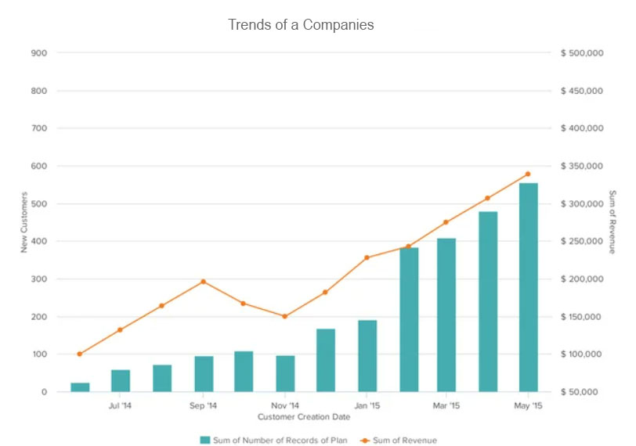

**CONCLUSION:**

The conclusion for an AI-driven exploration and prediction of company registration trends with the Registrar of Companies (RoC) project typically involves summarizing key findings, insights, and the overall impact of the project. In this project, we embarked on an AI-driven journey to explore and predict company registration trends using data obtained from the Registrar of Companies (RoC). The primary objective was to leverage machine learning techniques to gain insights into registration patterns and develop predictive models for future trends.